Eric Samuel Huddleston

Matthew Frierson

Group 14

11/14/2020

Section 001

**2.1 Task 1: Becoming a Certificate Authority (CA)**

First I start by moving openssl.cnf to my current working directory, which I created under /home/seed/Desktop using mkdir PKI2. In my case I dragged and dropped the file ‘openssl’ into this directory from /usr/lib/ssl, as shown below. This can also be accomplished using the mov command as well.

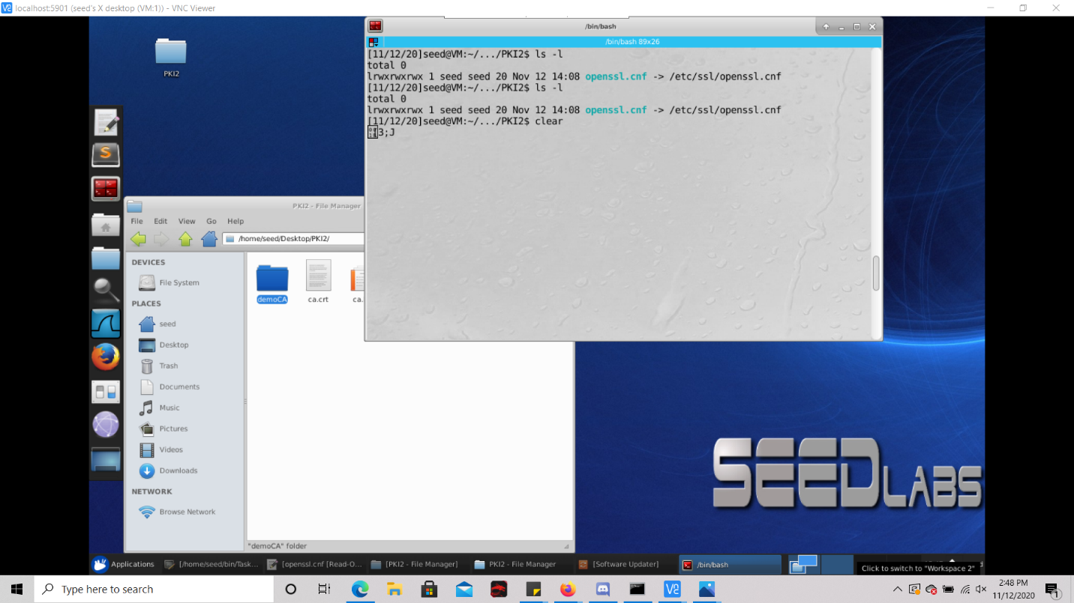

Next I create the necessary directories as specified in the CA_default section of the configuration file, and create the index file and put the single number 1000 into the serial file as instructed using echo, as seen below:

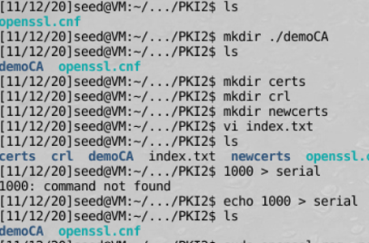

After creating the index file I moved the subdirectories into ./demoCA by using the mov command in a separate terminal window. As seen above after doing this when I ls on the last line shown above those subdirectories are contained under demoCA as necessary.

Now we need to generate a self signed certificate for the CA, so as to make the CA totally trusted and so the certificate which belongs to it can serve as the root certificate. I did this with the openssl command as so:

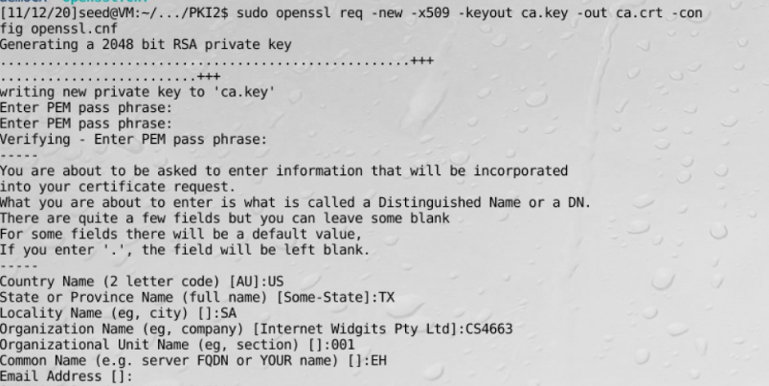

**Task 2: Creating a Certificate for SEEDPKILab2020.com**

For this task we must ensure the company ‘SEEDPKILab2020.com’ can get a digital certificate from a CA.

**Step 1: Generate public/private key pair.**

For this step we need to generate a public/private key pair for the company, specifically and RSA key pair with they keys being stored in server.key:

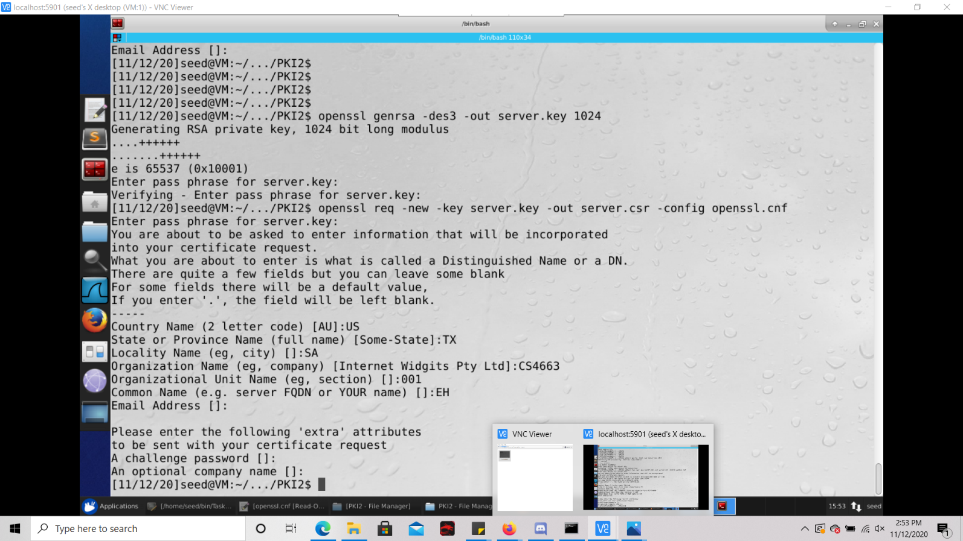

Since the server.key is an encoded text file, so in order to see the contents of it we must run the following command as such:

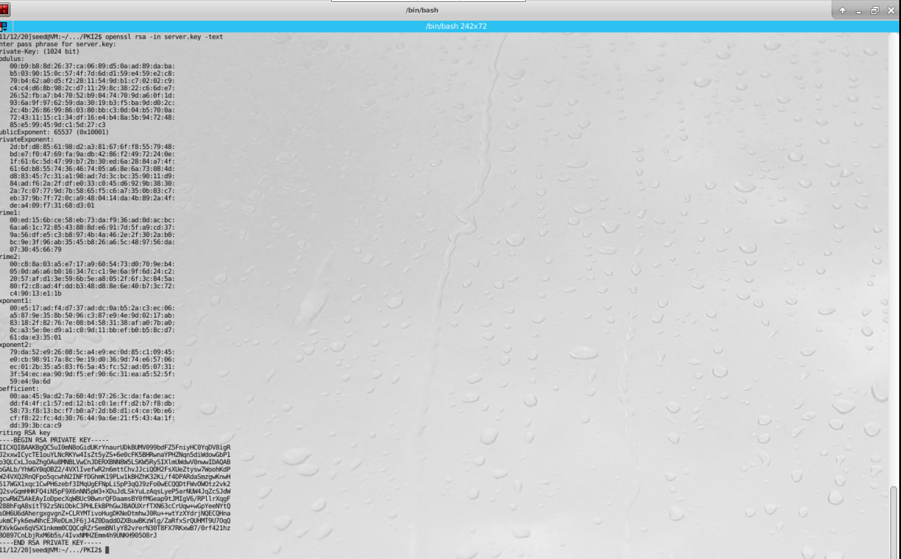

**Step 2: Generate a Certificate Signing Request (CSR)**

For this step we must generate a Certificate Signing Request, which will be sent to the CA, who will generate the certificate for the key. In this command I used SEEDPKILAB2020.com as the common name of the certificate request as shown below:

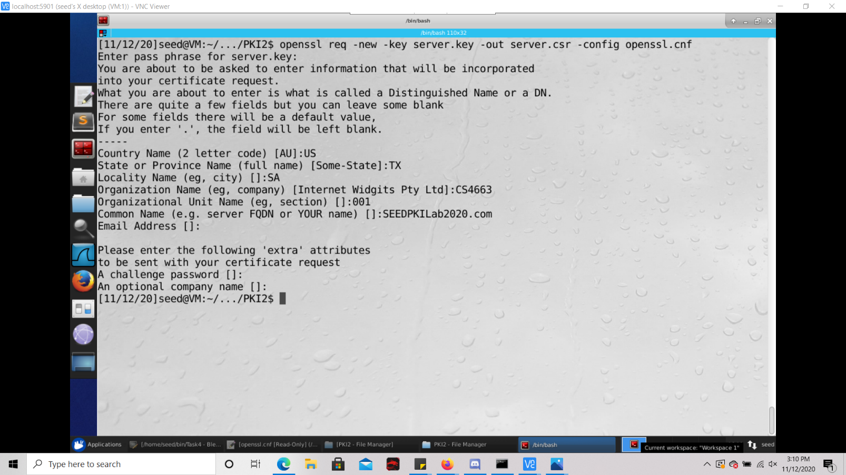

**Step 3: Generating Certificates**

For this step we must turn the csr (server.csr) into an X509 certificate (server.crt) using the ca.crt of the CA and ca.key as shown below:

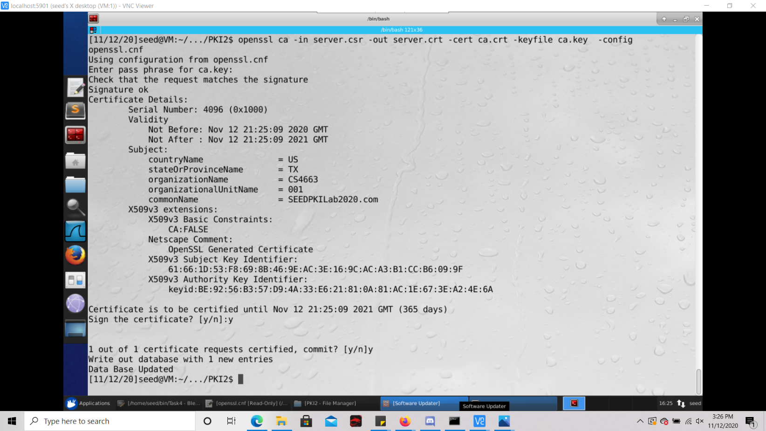

**2.3 Task 3: Deploying Certificate in an HTTPS Web Server**

Step 1: Configuring DNS.

For this step I simply open /etc/hosts from the PKI2 directory with the command as follows:



After executing this command we see a list of ip addresses and their corresponding host names:

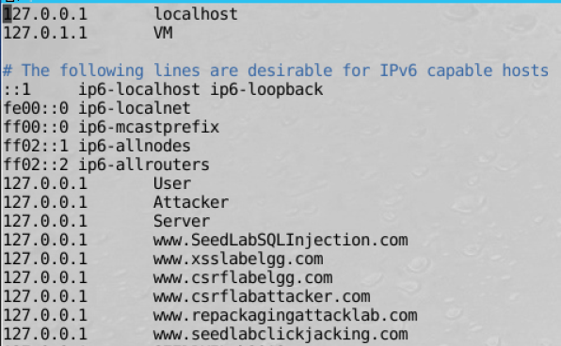

Now I add the IP address for the Certificate Authority, SEEDPKILab2020.com at the bottom of the file as such:

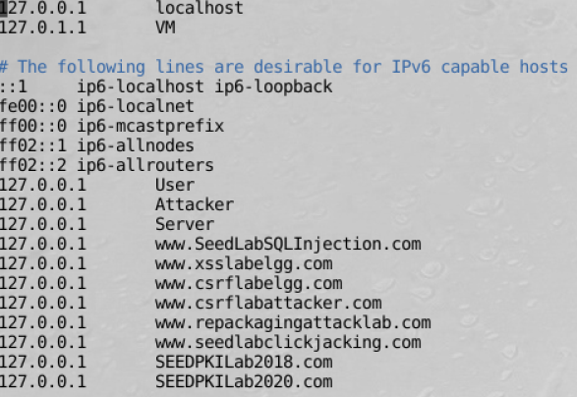

Step 2: Configuring the web server

For this step I launch the web server that was generated in the previous task using OpenSSL and the s_server command as so:

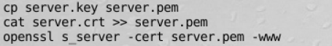

Step 3: Getting the browser to accept our CA certificate.

Next, for this step I load the certificate authority into Firefox by first clicking edit 🡪 preferences as so:

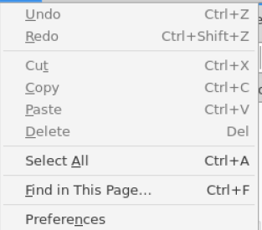

Then I click ‘view certificates’ button under Privacy and Security and import the CA file into the browser as follows:

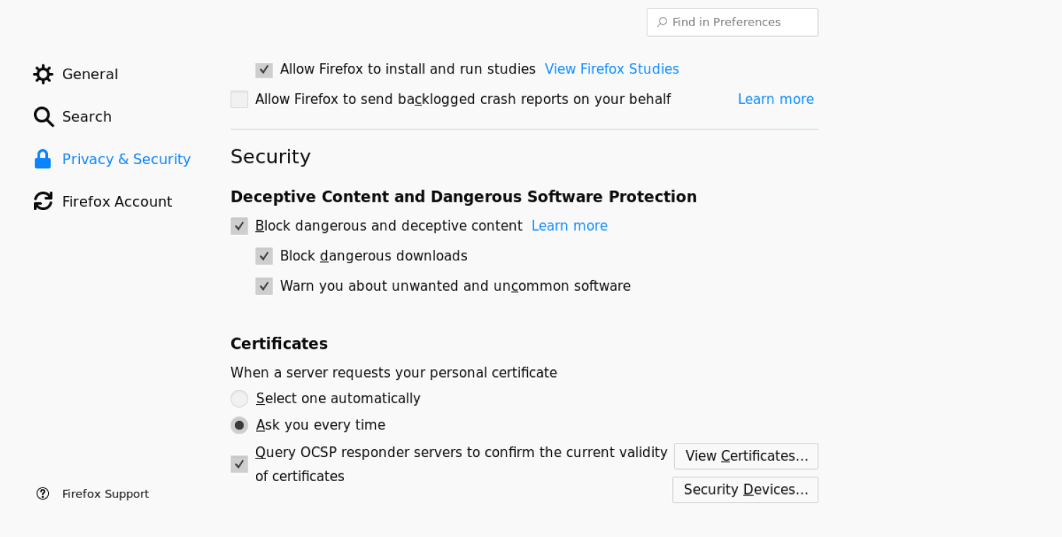

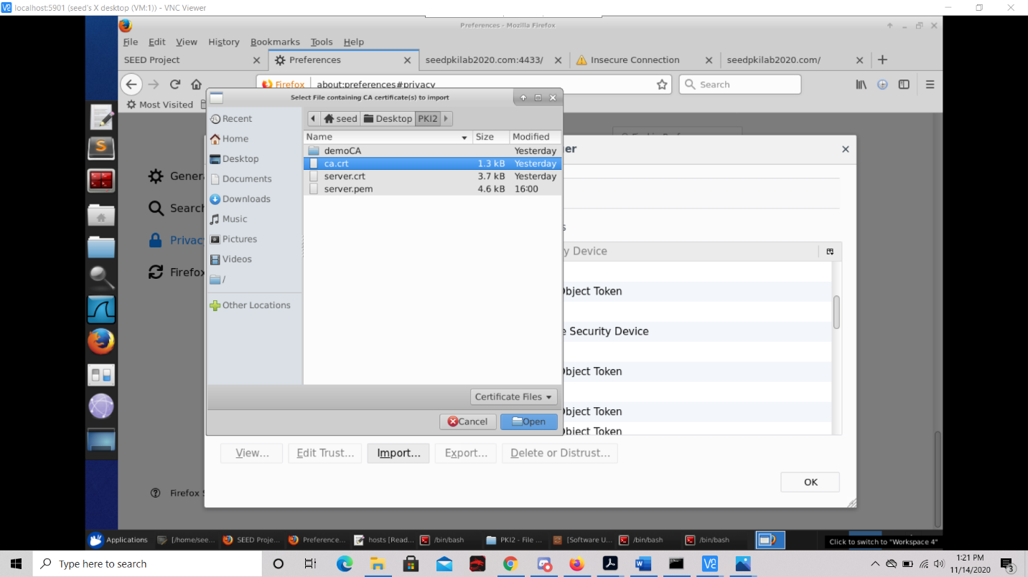

Now if we look at the Authorities under the Certificate Manager tab we can see that EH was added as a CA under the CS4663 organization:

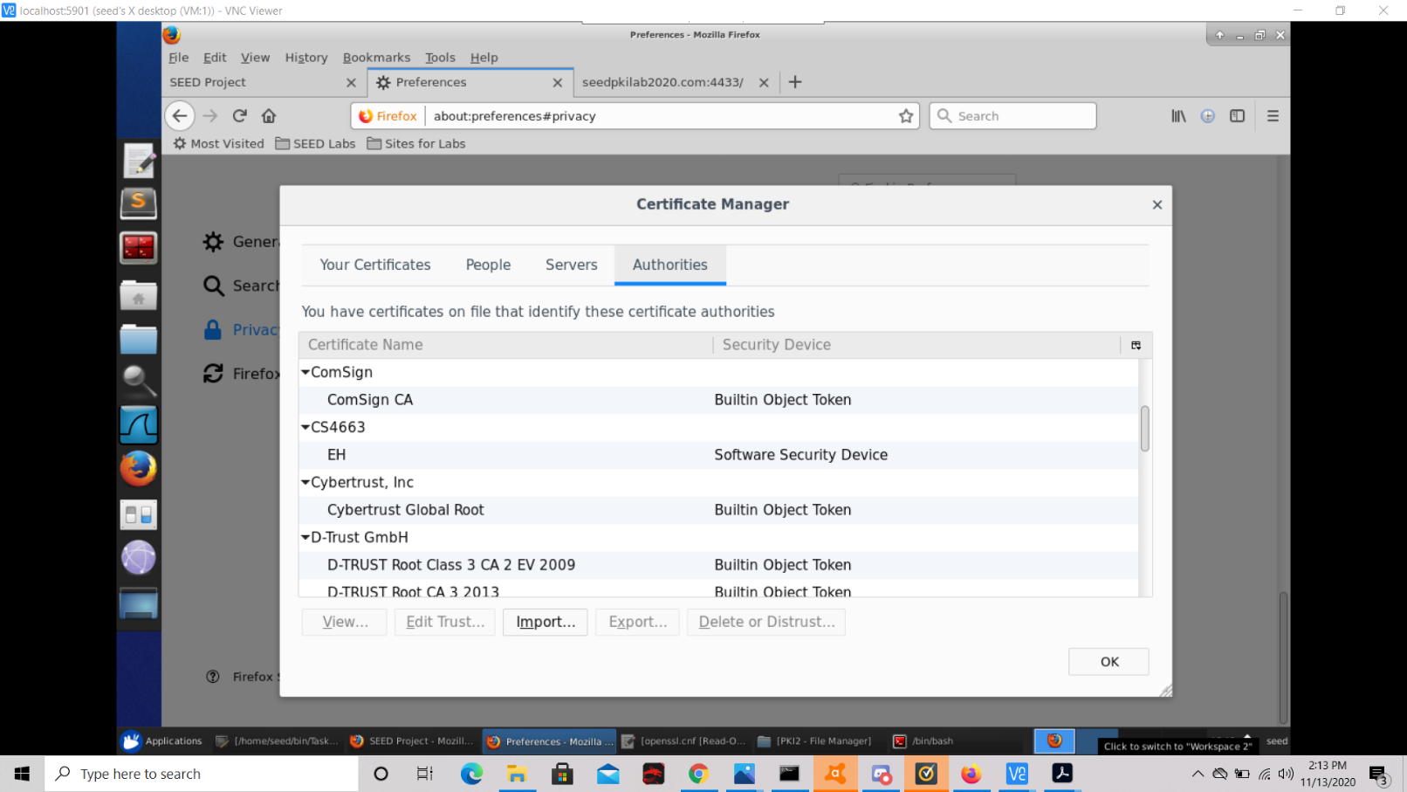

**Step 4. Testing our HTTPS website.**

Now, point the browser to https://SEEDPKILab2018.com: 4433. Please describe and explain your observations.

When we point the browser to seedokilab2020.com, we see that the command to launch the web server was successfully printed out onto the screen, and additionally the ciphers which are supported by the binary for s_server are also displayed on the web page. It also shows which ciphers are prevalent between the SSL endpoints.

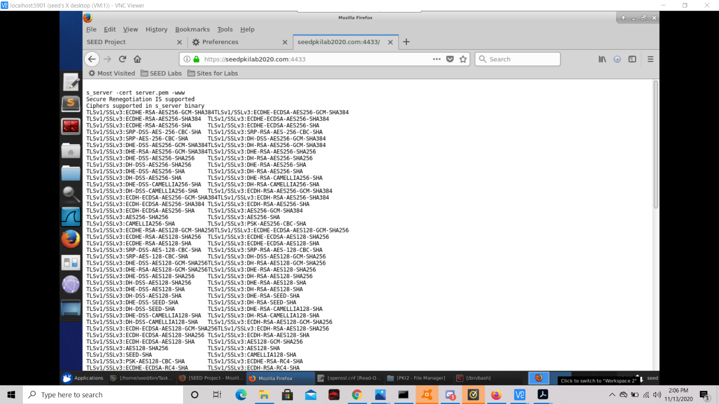

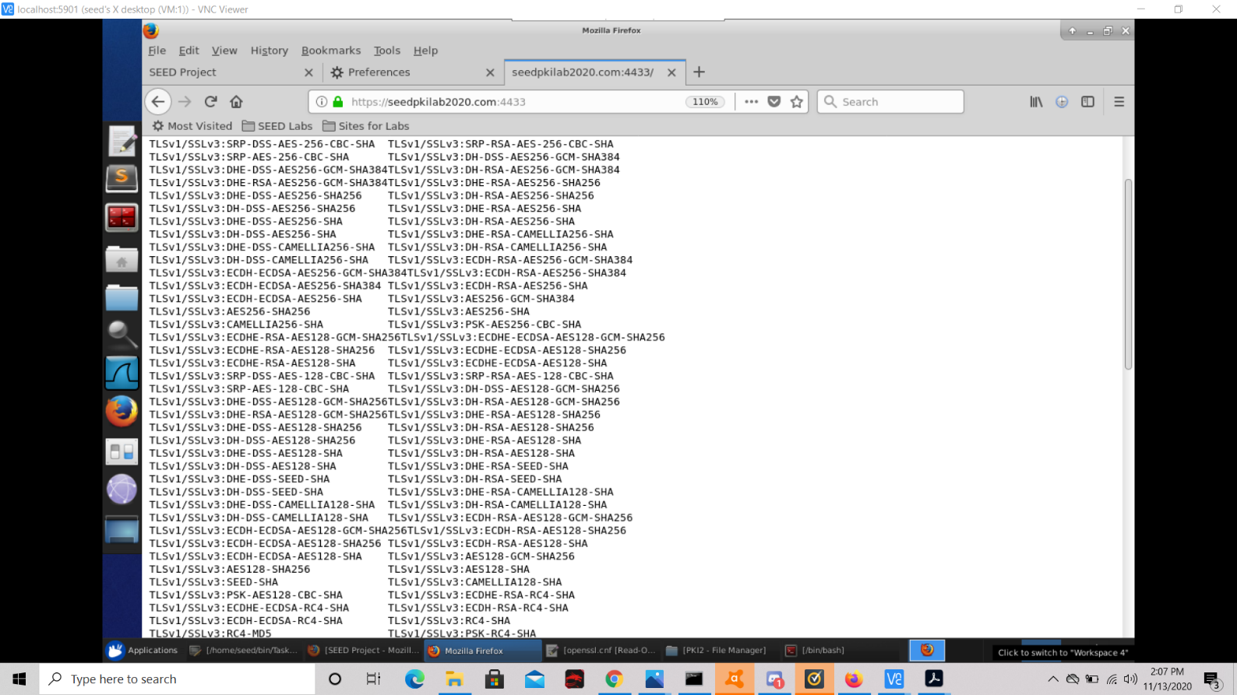

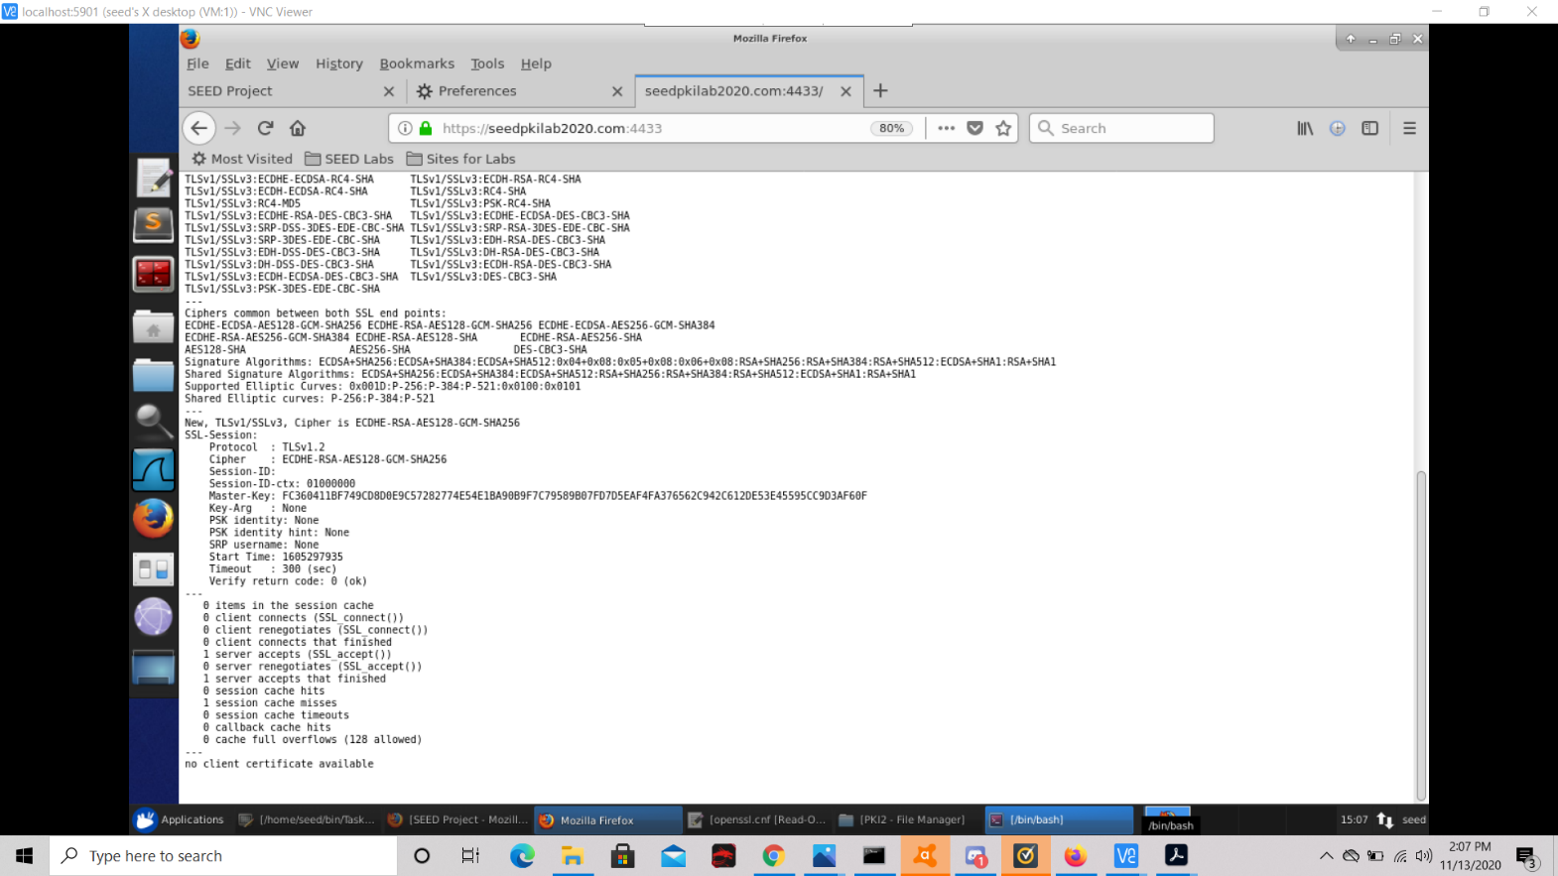

1. Modify a single byte of server.pem, and restart the server, and reload the URL. What do you observe? Make sure you restore the original server.pem afterward. Note: the server may not be able to restart if certain places of server.pem is corrupted; in that case, choose another place to modify.

For this subtask first we open server.pem as so:



Then, when go into it, it looks like so:

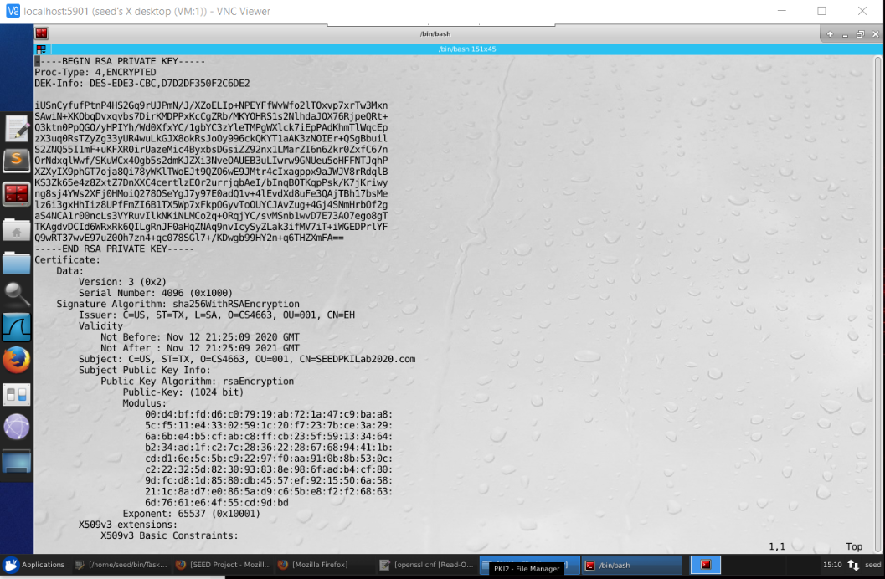

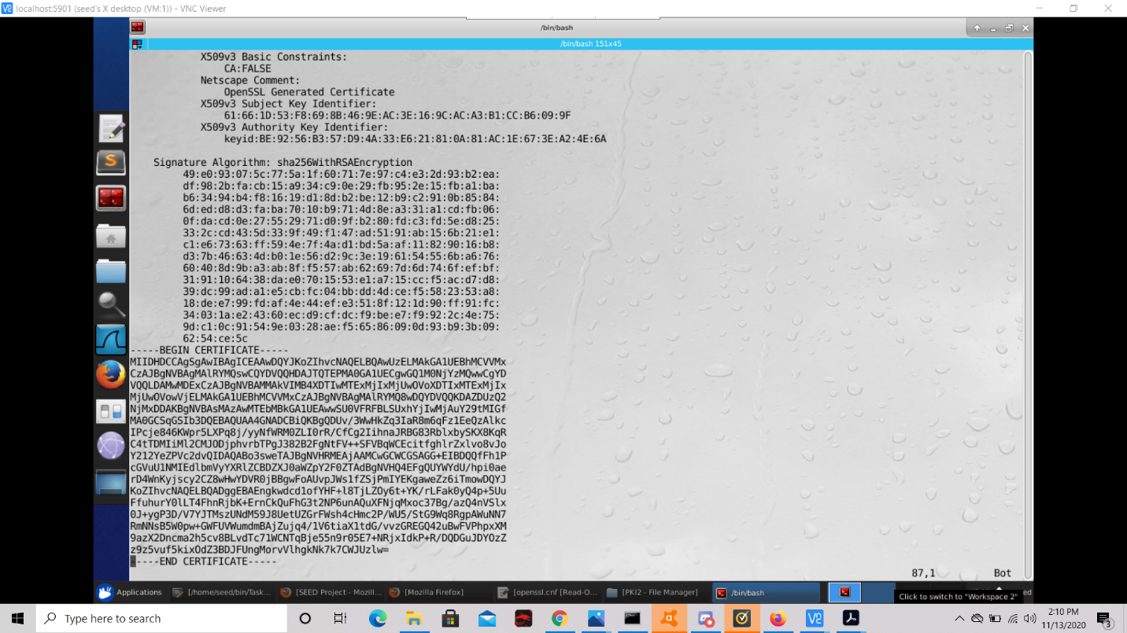

Here I will simply change the single byte of ‘ST=TX’ to ‘ST=VA’.



Now we can reload the site as so:

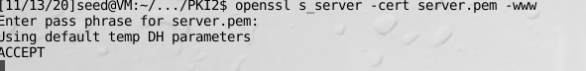

After doing this when we point to the same address again, we see that the Master Key and Start Time has changed between the two:

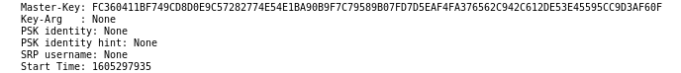

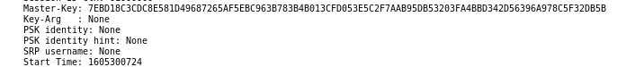

1. Since SEEDPKILab2020.com points to the localhost, if we use https://localhost:4433 instead, we will be connecting to the same web server. Please do so, describe and explain your observations.

If we change the web address to point the localhost directly, We get a connection error as shown below. This is because the site is not able to recognize the certificate authority through the ‘ca.crt’ and ‘server.crt’ files, and because we are not telling the site what organization that the certificate authority is coming from through these files.

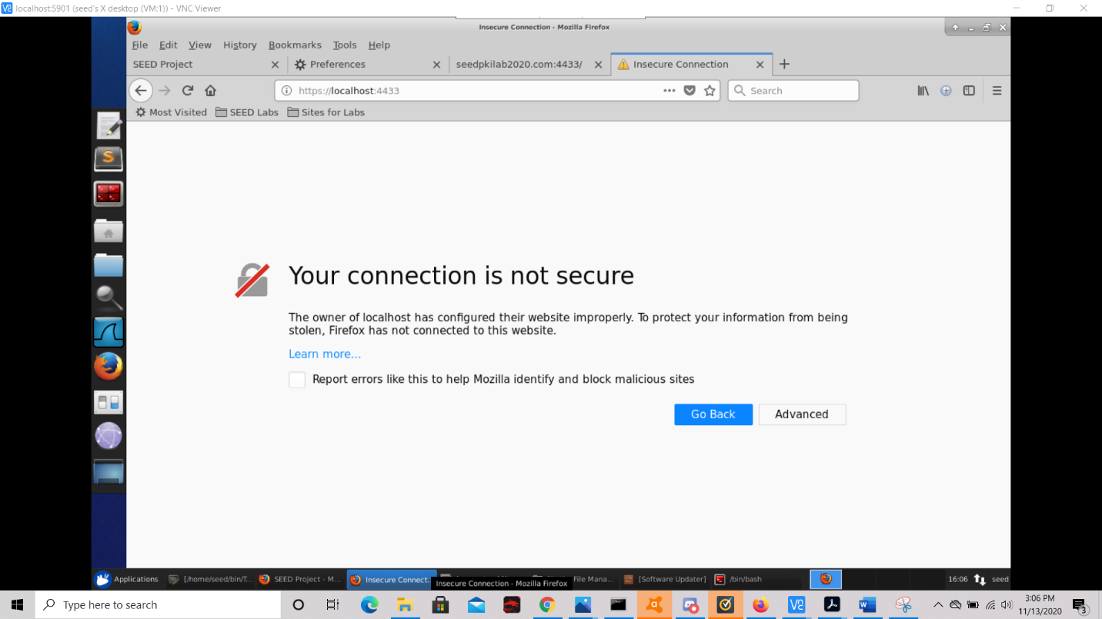

* 1. **Task 4: Deploying Certificate in an Apache-Based HTTPS Website**

First we start by copying the server’s certificate and key files to CERT.pem and KEY.pem and moving the CERT.pem file to the apache2 ssl subdirectory..:

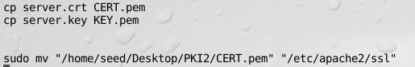

Now I open a new terminal and switch to the apache2 subdirectory…

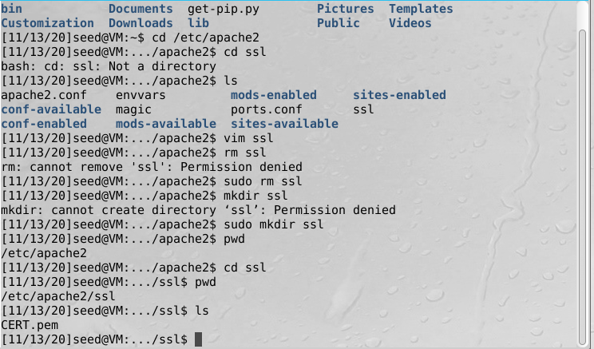

Now I go back to PKI2 directory, moving KEY.pem to /etc/apache2/ssl



Now I change back to ssl directory and cd into the apache sites-available directory. Then I open default-ssl.conf…

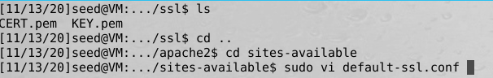

Now I set up virtual hosts for SEEDPKILab2020.com and facebook.com…

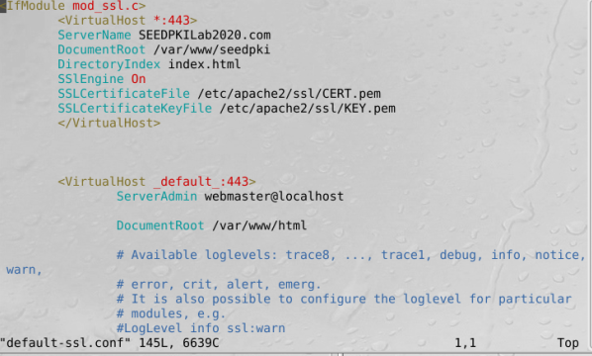

Now I switch to another new terminal and create the document root for the SEEDPKILab2020.com virtual host as well as the index.html for the site:

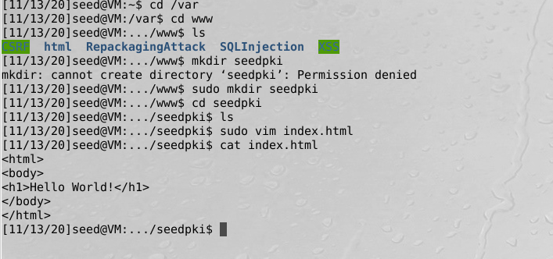

Now I switch back to PKI2 directory and run the commands to Test the apache config. File, ebale ssl module, enable the site we edited, and restart apache:

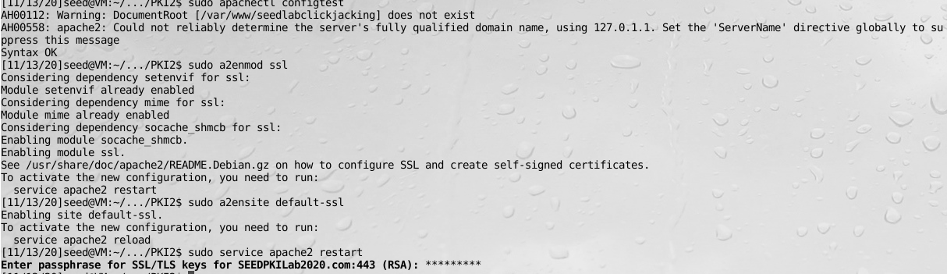

Now if I visit seedpkilab2020.com, we see that the HTTP server is successfully rendering the site:

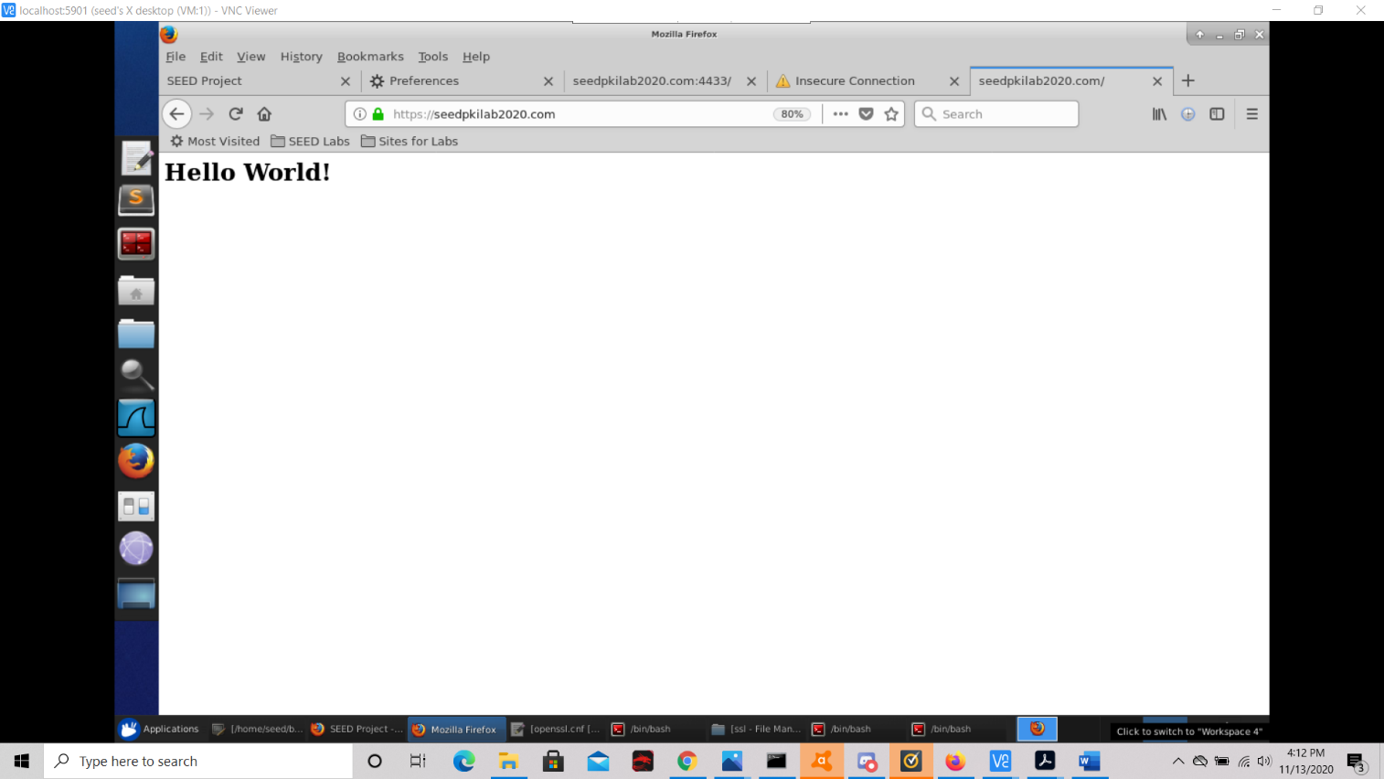

* 1. **Task 5: Launching a Man-In-The-Middle Attack**

Step 1: Setting up the malicious website.

For this step we must impersonate example.com (In this case Instagram.com) using the same Apache server. To achieve first I switch back to the terminal under /etc/apache2/sites-available as shown below:

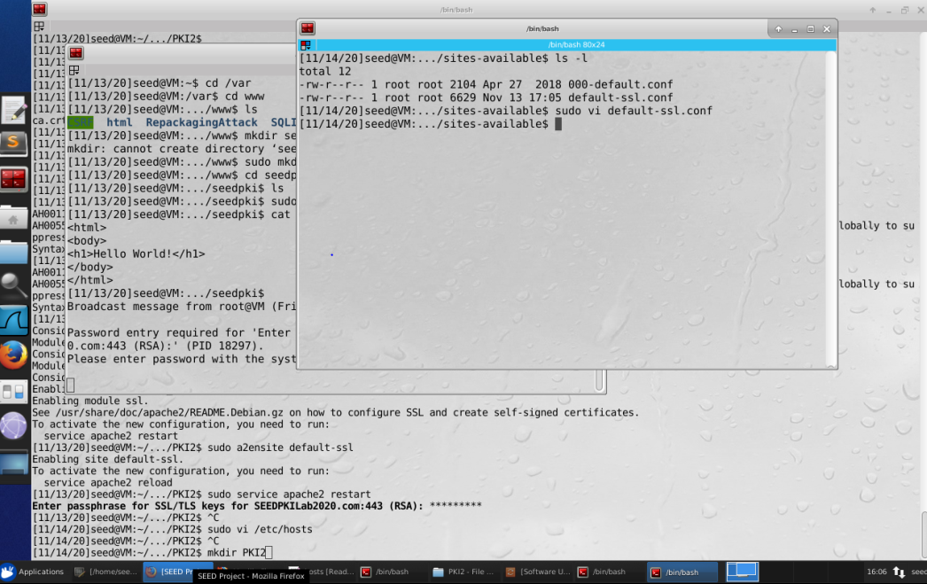

Then I add a new virtual host to default-ssl.conf as shown below, which will impersonate Instagram.com:

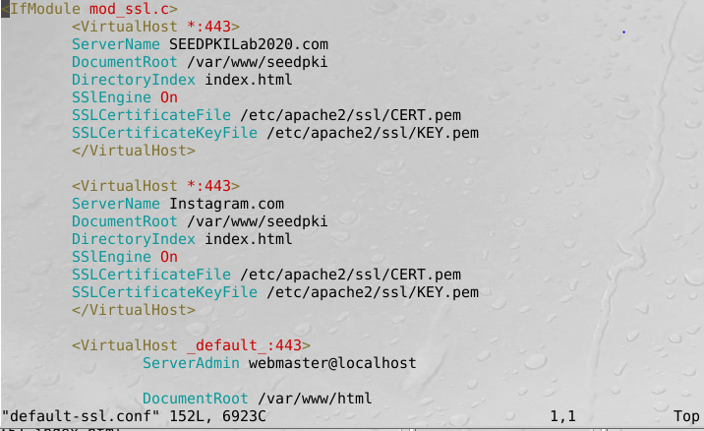

Then I switch back my terminal under the directory /home/seed/Desktop/PKI2, and execute the command ‘sudo apachectl configtest’ as follows:



**Step 2: Becoming the man in the middle**

Then I open up a new terminal (under the root directory), and execute the command ‘sudo nano /etc/hosts’ in order to edit the /etc/hosts file as follows:



Then I add a new CA for Instagram.com as follows:

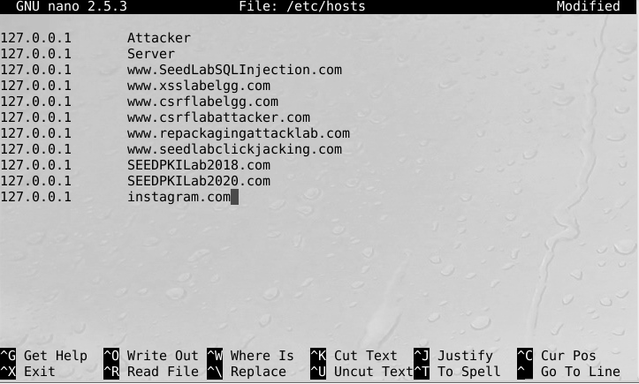

**Step 3: Browse the target website.**

Then I switch back to the terminal under the path /home/seed/Desktop/PKI2, then when I open up Firefox and go to the address ‘instagram.com’, the apache default page for the site is displayed through this address rather than the Instagram site, as seen below:

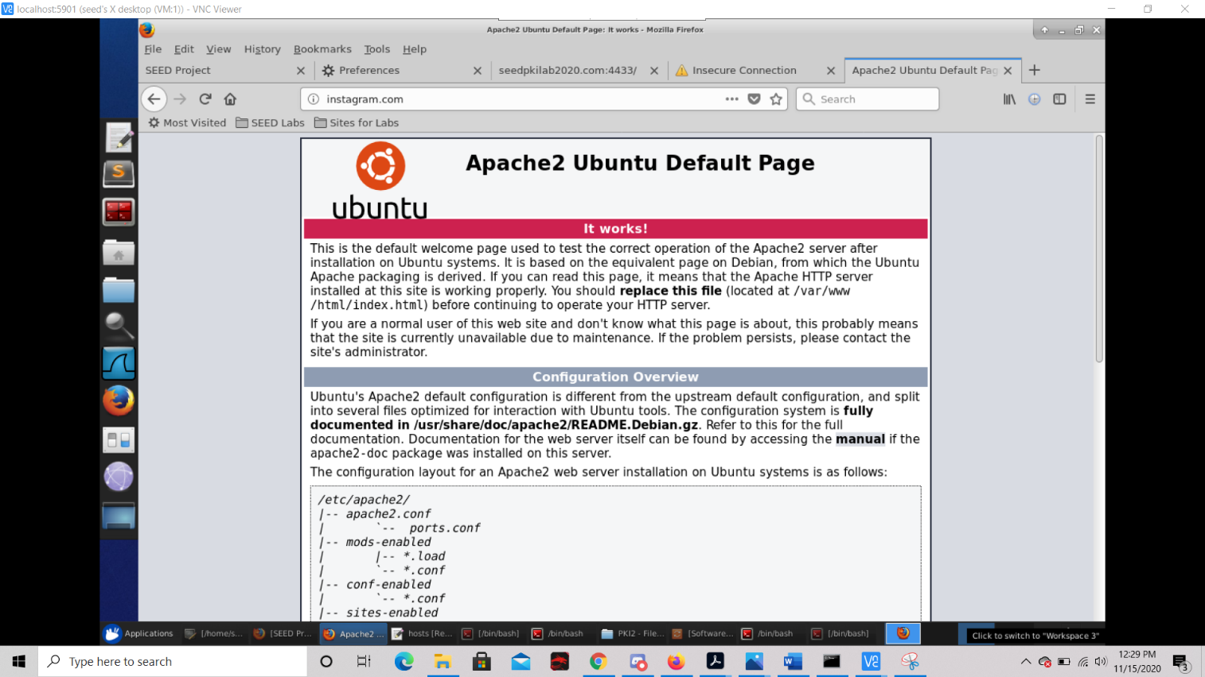

From this I deduce that the launching of this basic MITM attack was successful, since we “attacked” the DNS by modifying the victim’s /etc/hosts file to emulate what would result from DNS cache poisoning attack, and as seen from the screenshot above, when the victim’s machine attempts to find out the IP address of the target server, it instead is yielded the IP address of our server, and the victim is greeted with the Apache default page for our server, as opposed to the target page of Instagram.

* 1. **Task 6: Launching a Man-In-The-Middle Attack with a Compromised CA**

Now I switch back to the terminal under /home/seed/Desktop/PKI2 path, and start by creating a new certificate signing request for Instagram.com as so:

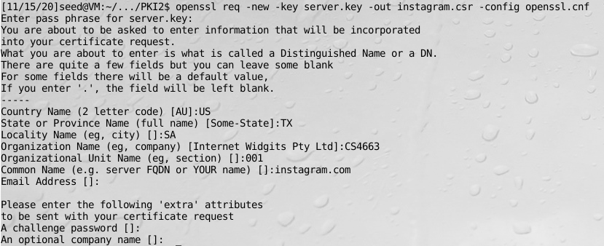

Next, I generate the certificates for Instagram.com, turning the csr into an X509 certificate, by using the CA’s ca.crt and ca.key:

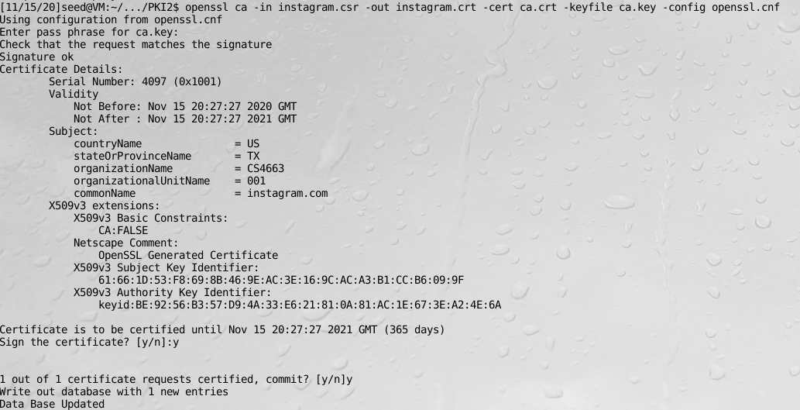

Now I move the information from both the key file and certificate file into the pem file, but this time for Instagram.com, as opposed to SEEDPKILab2020.com. I also copy the Instagram certificate file into an pem file, and move CERT2.pem to the ssl directory /etc/apache2:

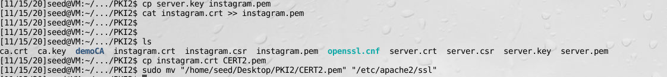

Now I switch to the previously opened terminal under /etc/apache2/ sites-available, cd to ssl and verify that ‘pem’ files for the Certificates and key were probably moved over, then change back to the sites-available directory:

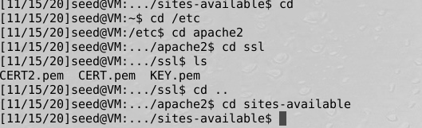

Now I open the configuration file for sites-available as so: 

Now I modify the already existing virtual host for Instagram, but this time using the ‘company’ or common name we dubbed ‘instagram.com’, which has the key and certificate files, and we also use modify the virtual host to use the new pem file dubbed ‘CERT2’, which uses the newly generated key and certificate information:

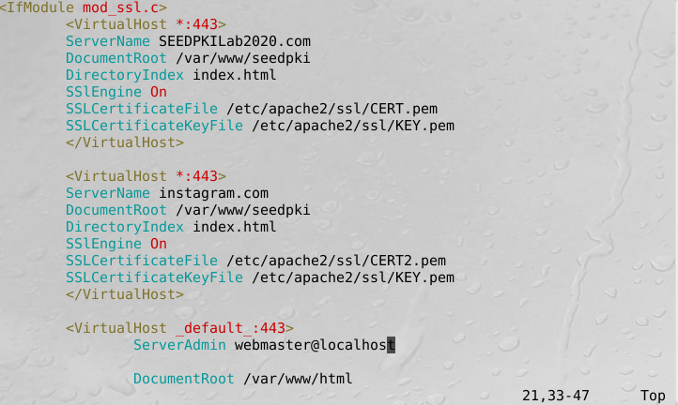

Now I switch back to the terminal under the /home/seed/Desktop/PKI2 path and restart the apache server using the following command:



Now if I go to Firefox and open Instagram.com but this time with the https protocol we see that the victim is redirected to our html output from /var/www, so because the CA was compromised, the victim’s machine is not yielded the IP address of our server, but is also fully tricked into thinking that the root of Instagram.com is in fact the root of our server, ‘index.html’, and that the key and certificate files we generated belong to Instagram.com:

